**Ayesha Zubair**

**52916**

**OS Lab 5**

**Task 1:**

Run all switches with **uname** command.

-r, -m, -p, -I, -o, -a, -v, -n

And define in one line about these commands according to your understanding.

**Solution:**

**Uname –r:** gives the kernel information

**Uname -m:**  hardware name of the machine

**Uname –p:** gives information about the type of processor

**Uname –i:** gives information about the hardware

**Uanme –o:** prints the details of the operating system

**Uname –a:** gives the full detail of the operating system

**Uname –v**: detail of the version of kernel

**Uname** –**n:** prints the hostname of the machine

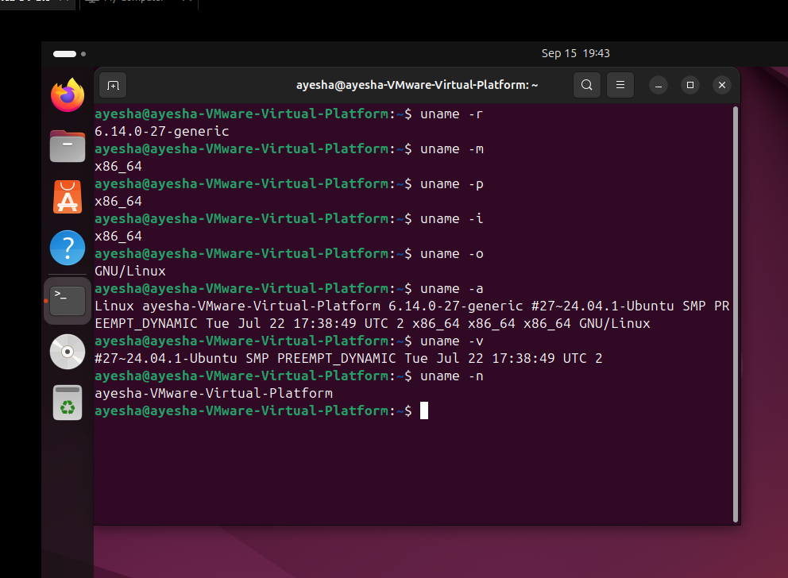

**Task 2:**

Create new file named **labSort** and insert following text

End of file

6 apples

file to be sorted

apple on the table

23 years old

File To be Sorted

78 apples

Class

3 bananas

99 sort files

**Solution:**

**Creating file : labSort**

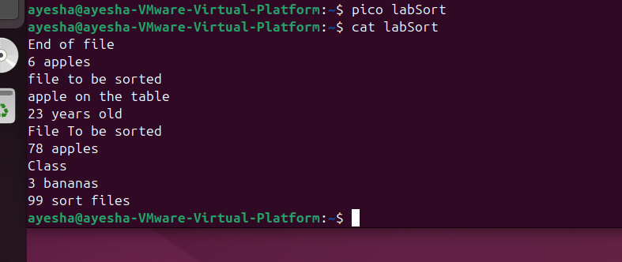

**Sorting using simple “sort”:**

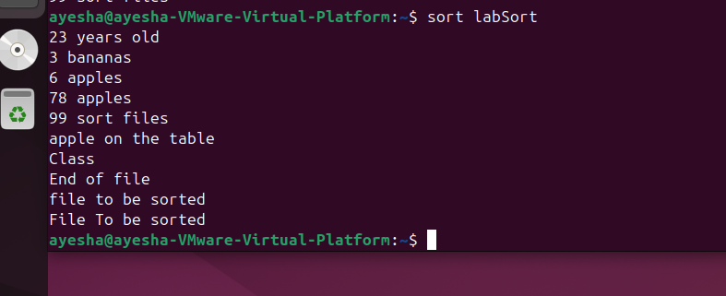

**Sorting using “sort –r”:**

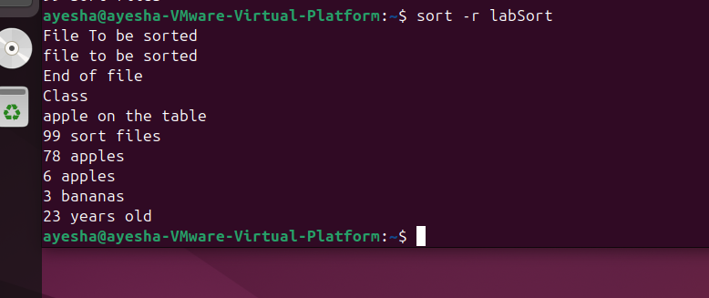

**Sorting using “sort –n”:**

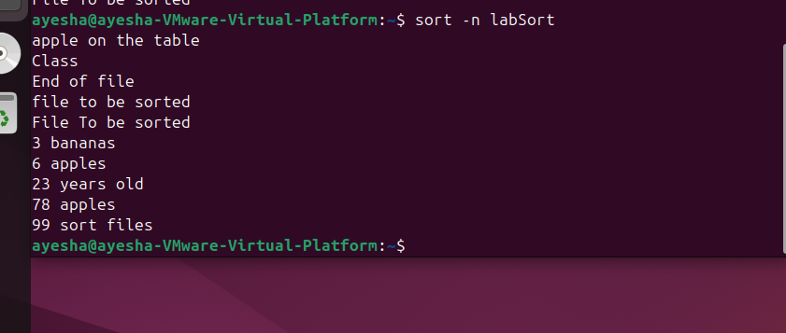

**Sorting using “sort –f”:**

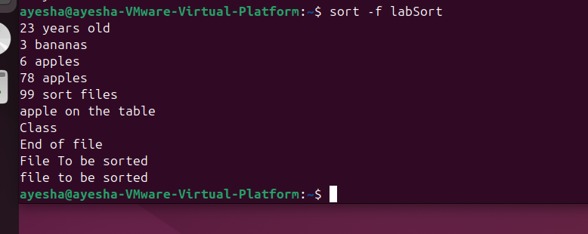

**Sorting using “ sort –k1”:**

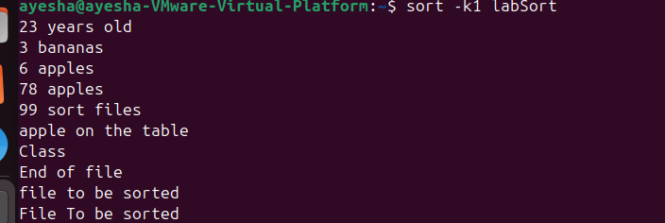

**Sorting using “sort –k2”:**

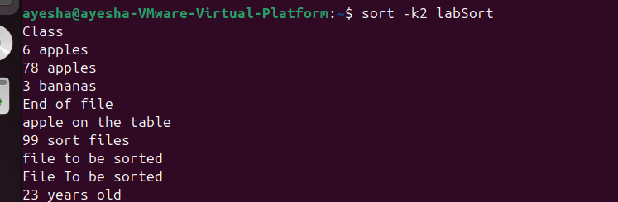

**Task 3:**

Create another file with name **SortLabNumeric** two columns in it.

12 Online classes

6 Network security

14 Hacking stories

7 Tom and jerry

13 People of Pakistan

One column contains numeric values while other contain text. Now perform sorting on both columns. Also perform **-n** switch on both columns again and observe the pattern.

**Solution:**

**Creating file and adding text:**

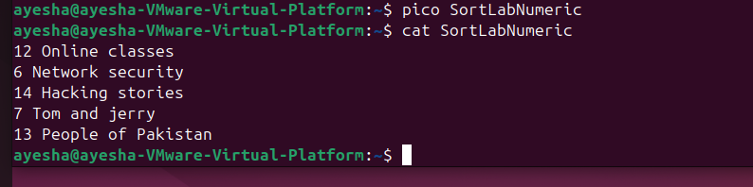

**Sorting 2nd column: (sorts the 2nd column alphabetically)**

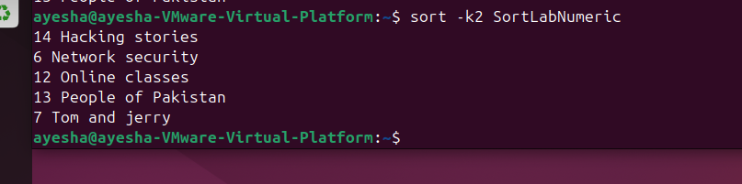

**Sorting 1st column: (according to the asci)**

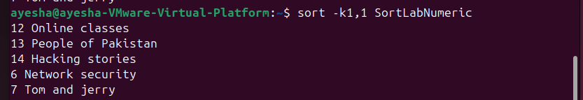

**Sorting using –n:**

**(Arranges the 1st column in ascending order)**

